**Apache2**

1. Search and click on EC2

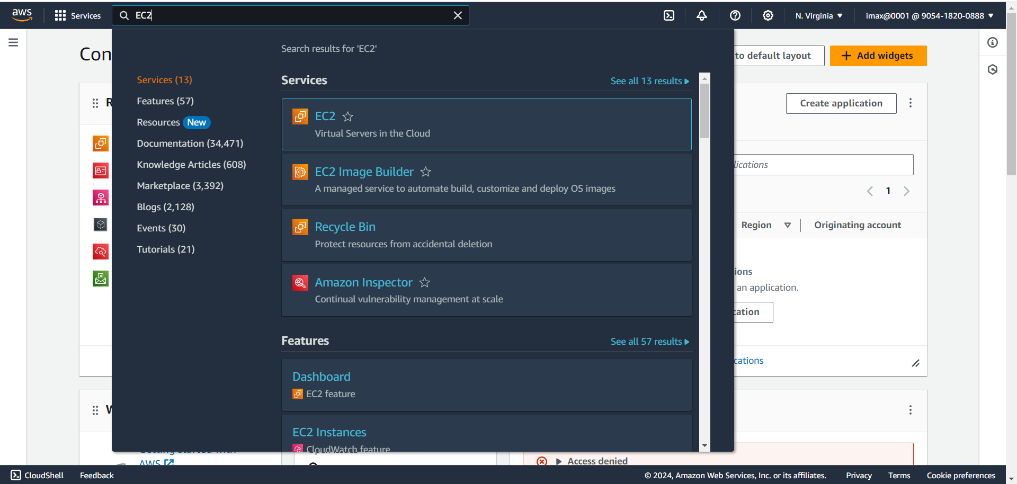

1. Click on Launch instance

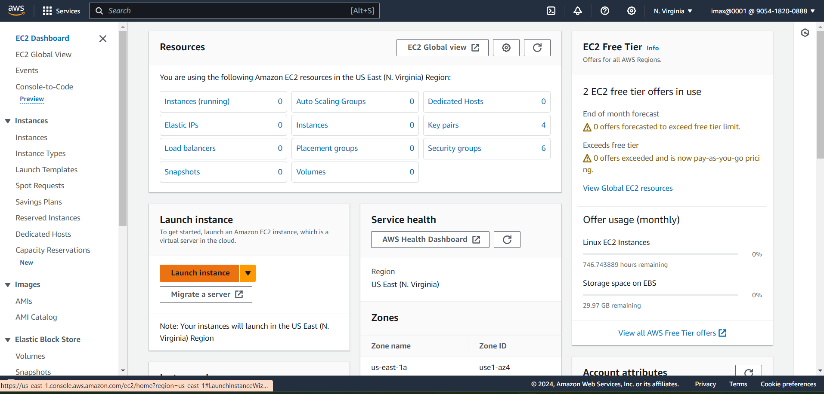

1. Select Ubuntu as Amazon Machin Image(Free tier eligible)

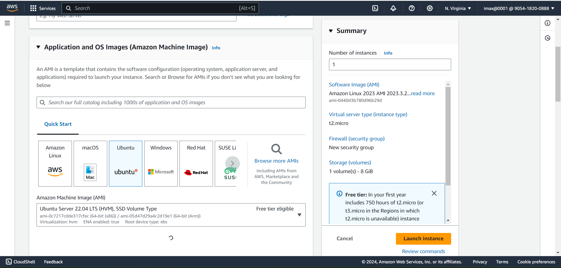

1. Select Instance type(t2.micro) and key pair in drop menu

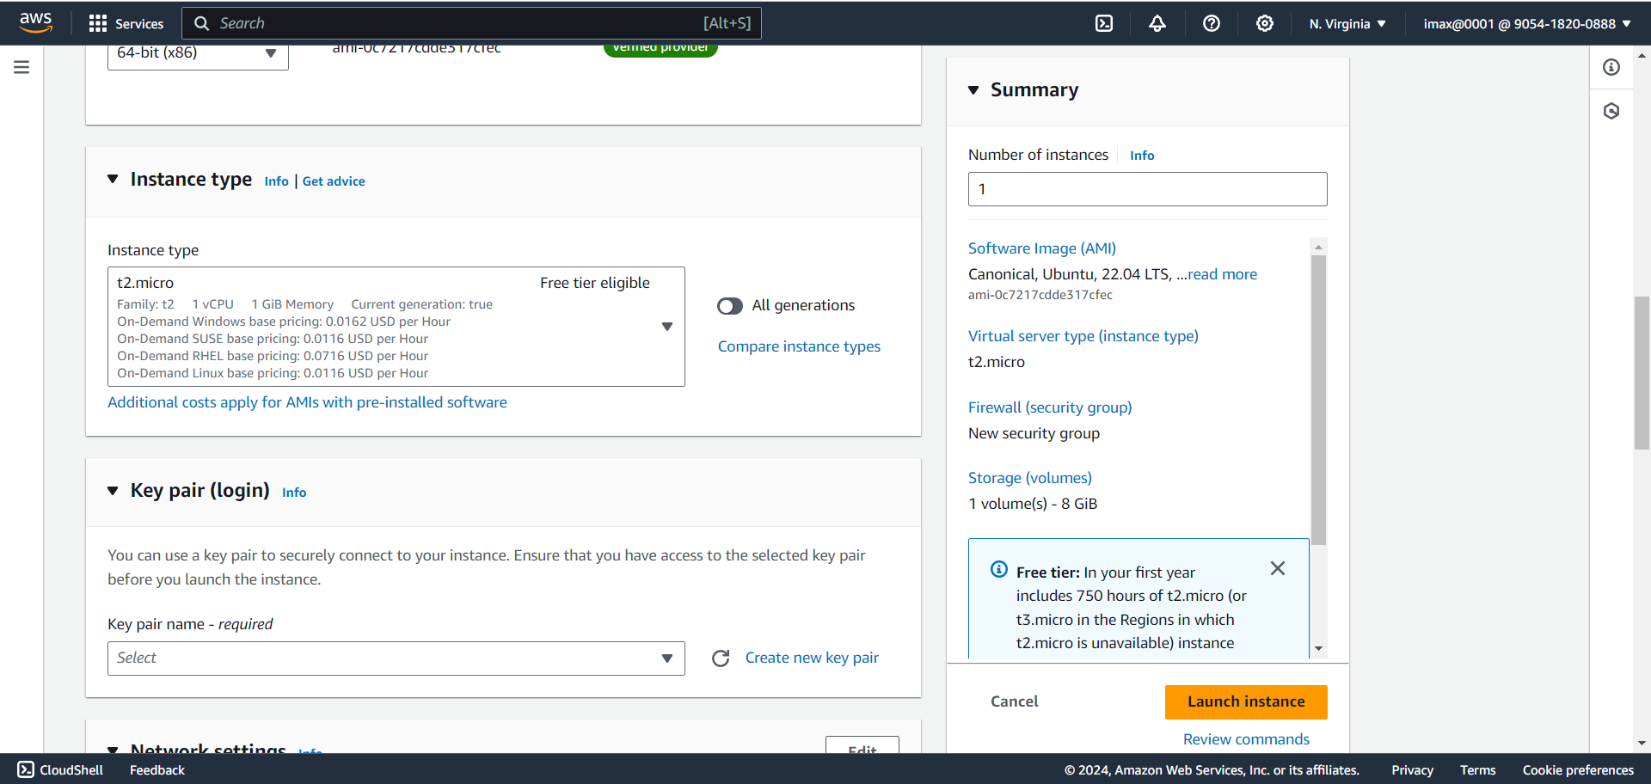

1. In Network section in security group select HTTPS and HTTP and SSH checkbox

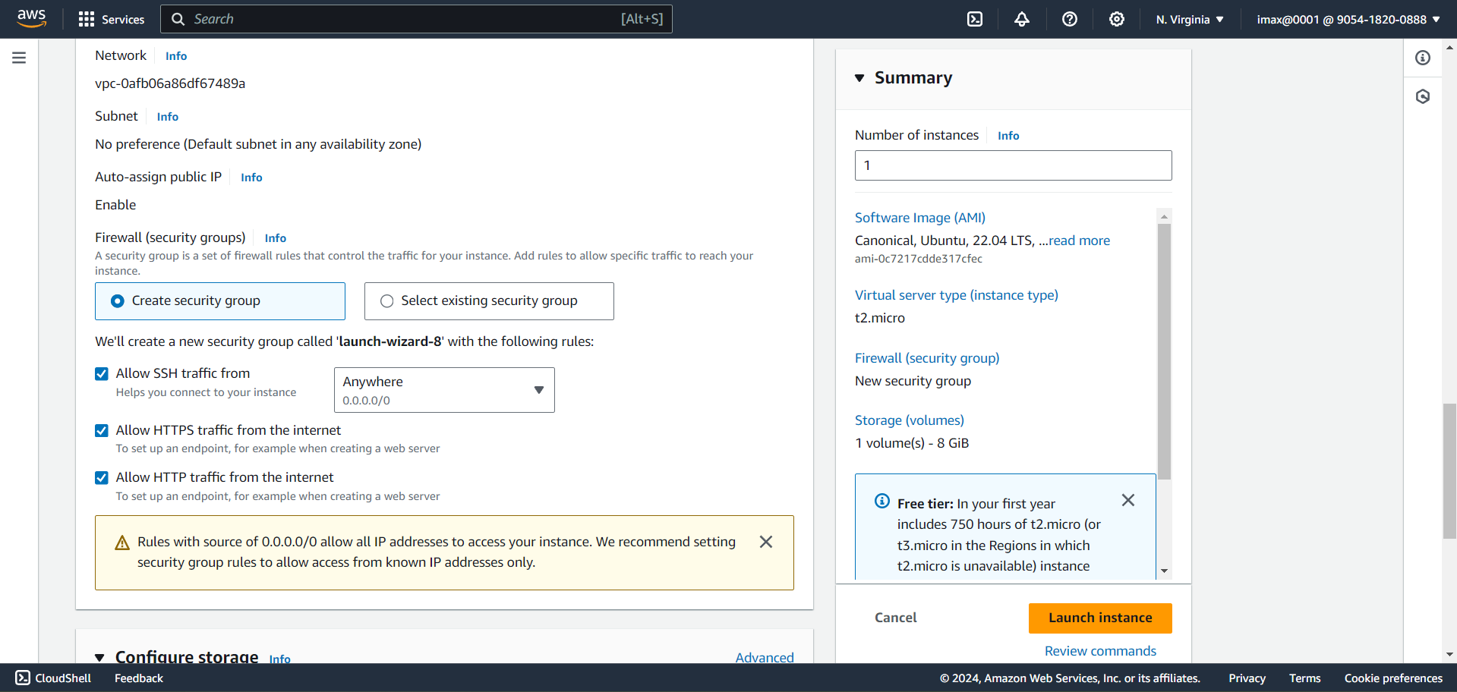

1. In Configure Storage not doing anything just click on ‘Launch instance’.

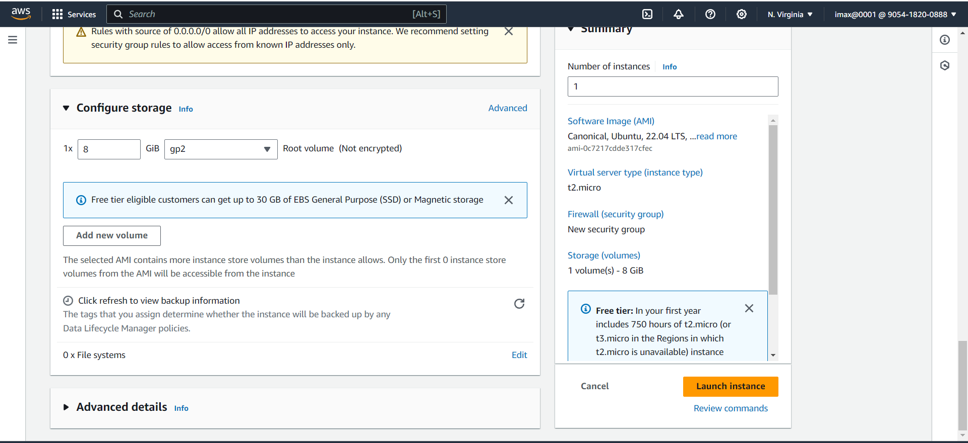

1. Machine launch successfully

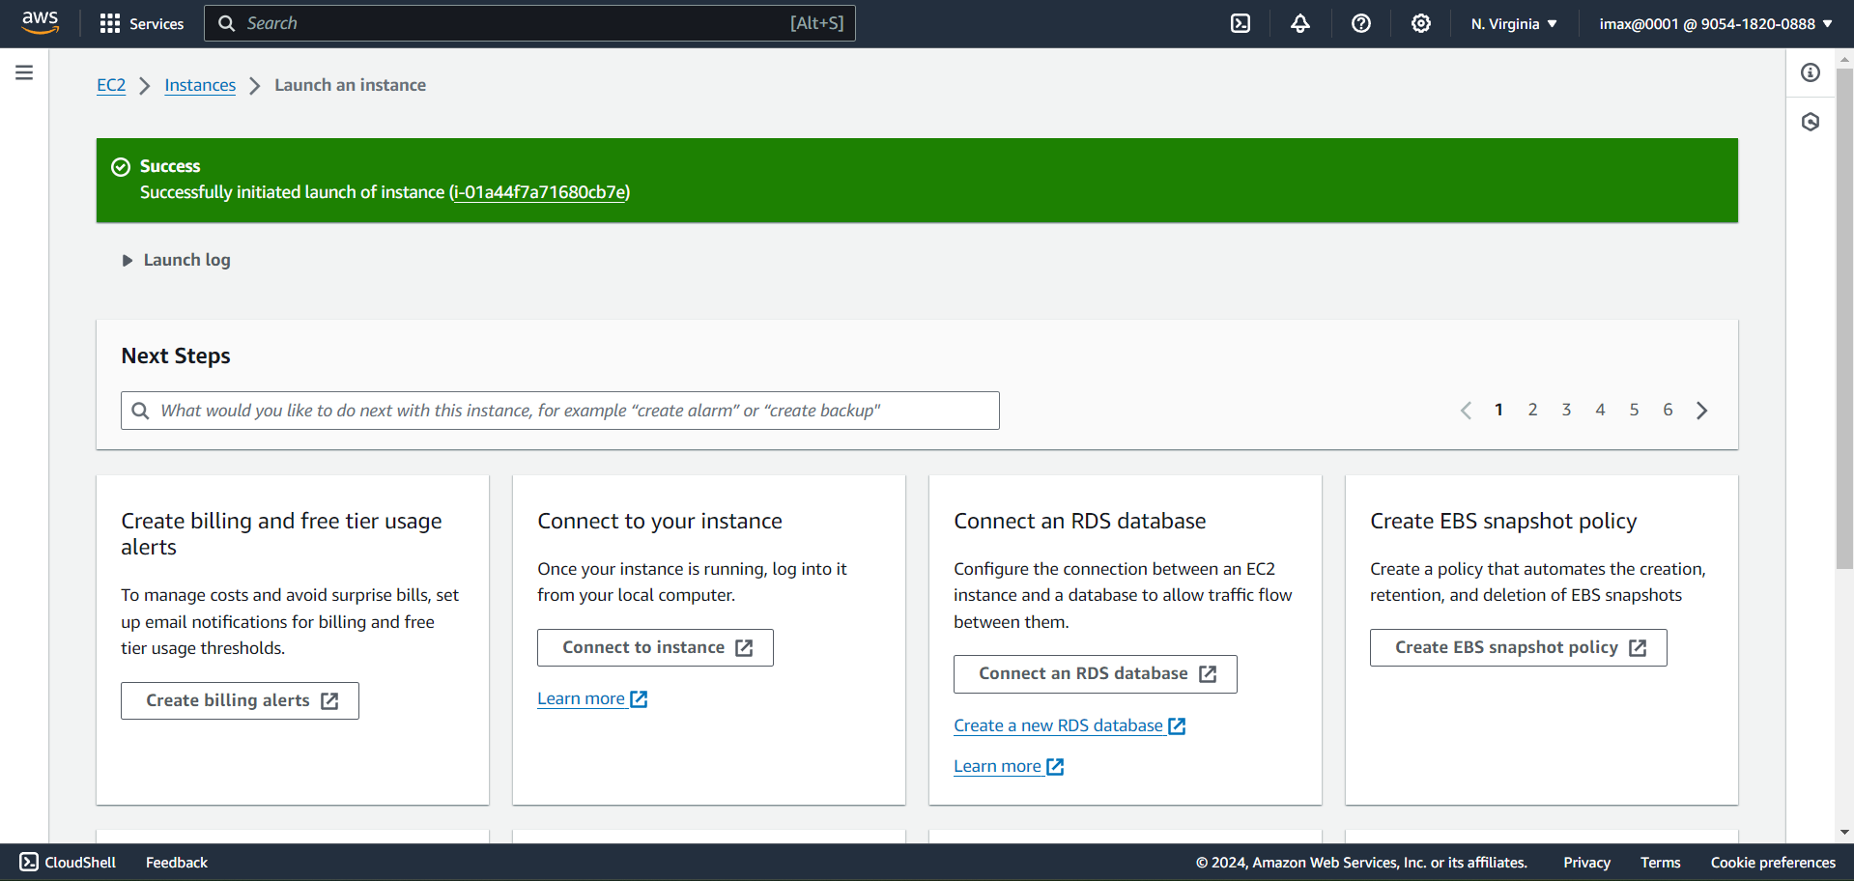

1. Click on View all Instances

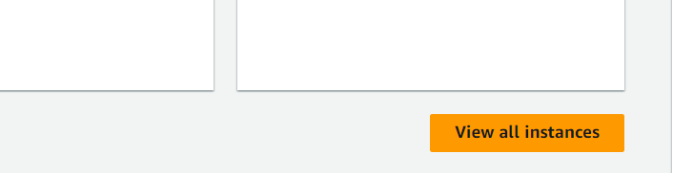

1. Copy that public Ip and hit on web browser

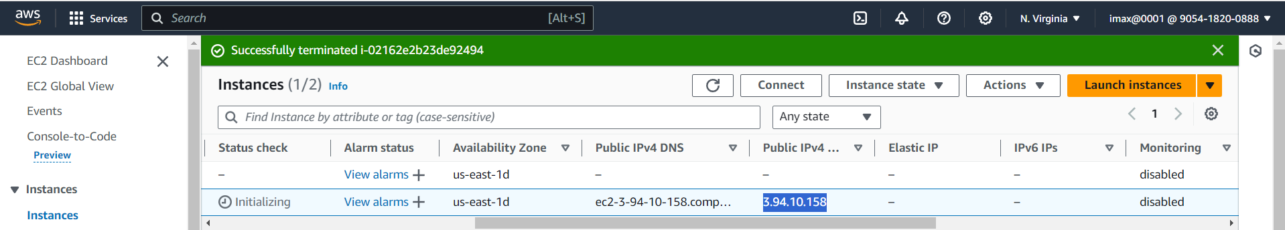

1. After hit public Ip in Web Browser the page display like this because the web server is not configure yet

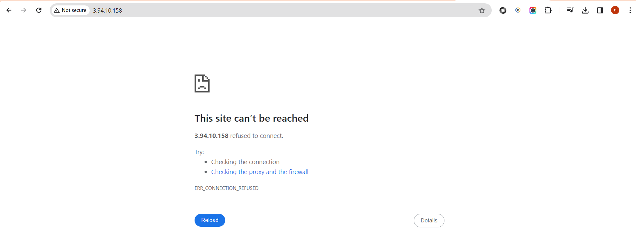

1. Right click on that instance and click on connect

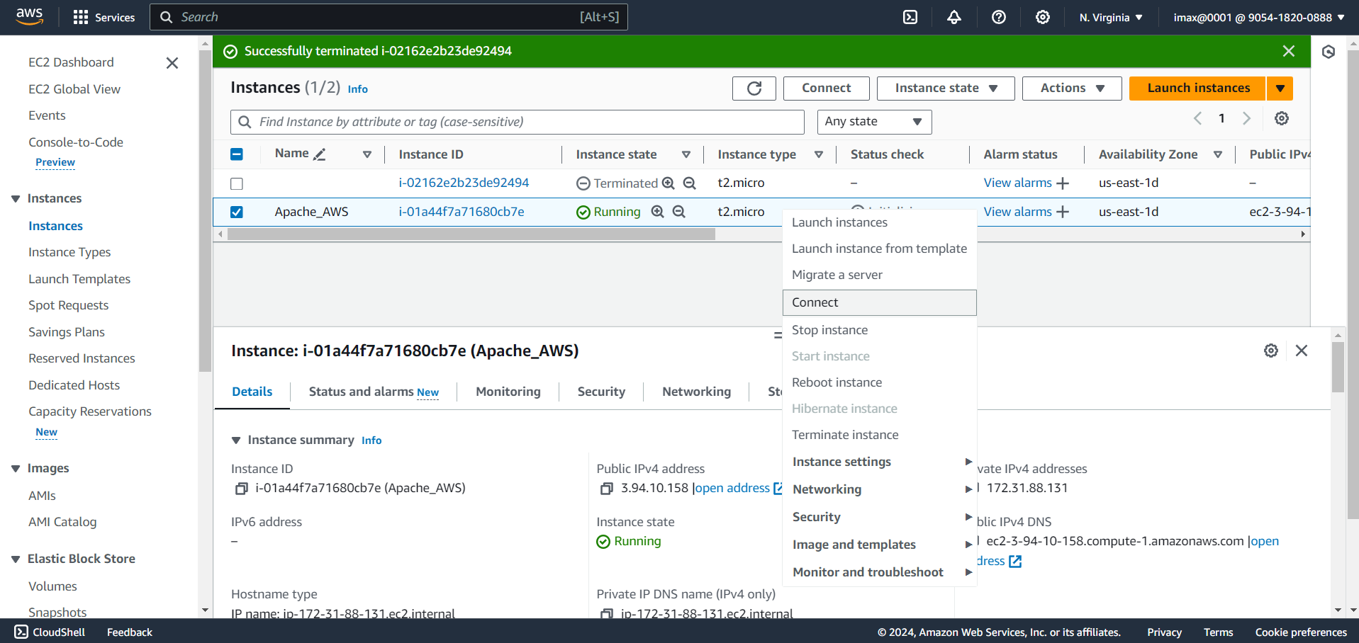

1. Click on Connect

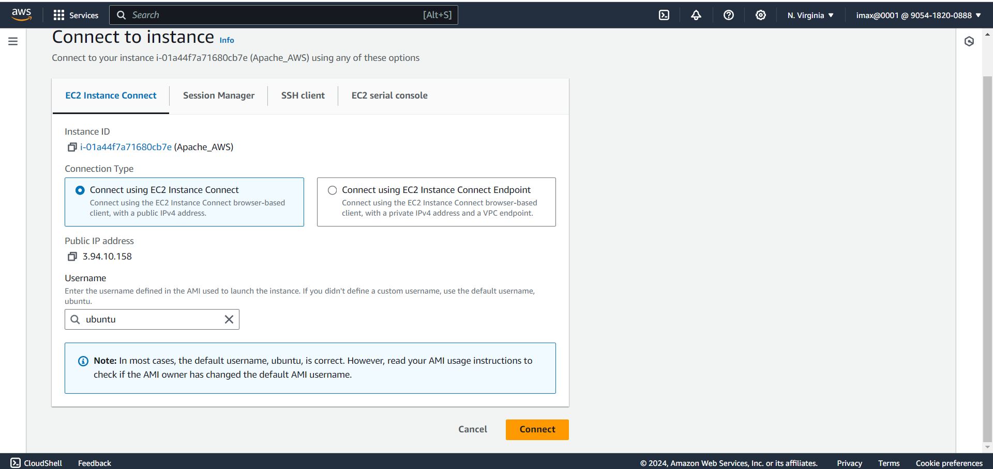

1. After Click on Connect the terminal will open

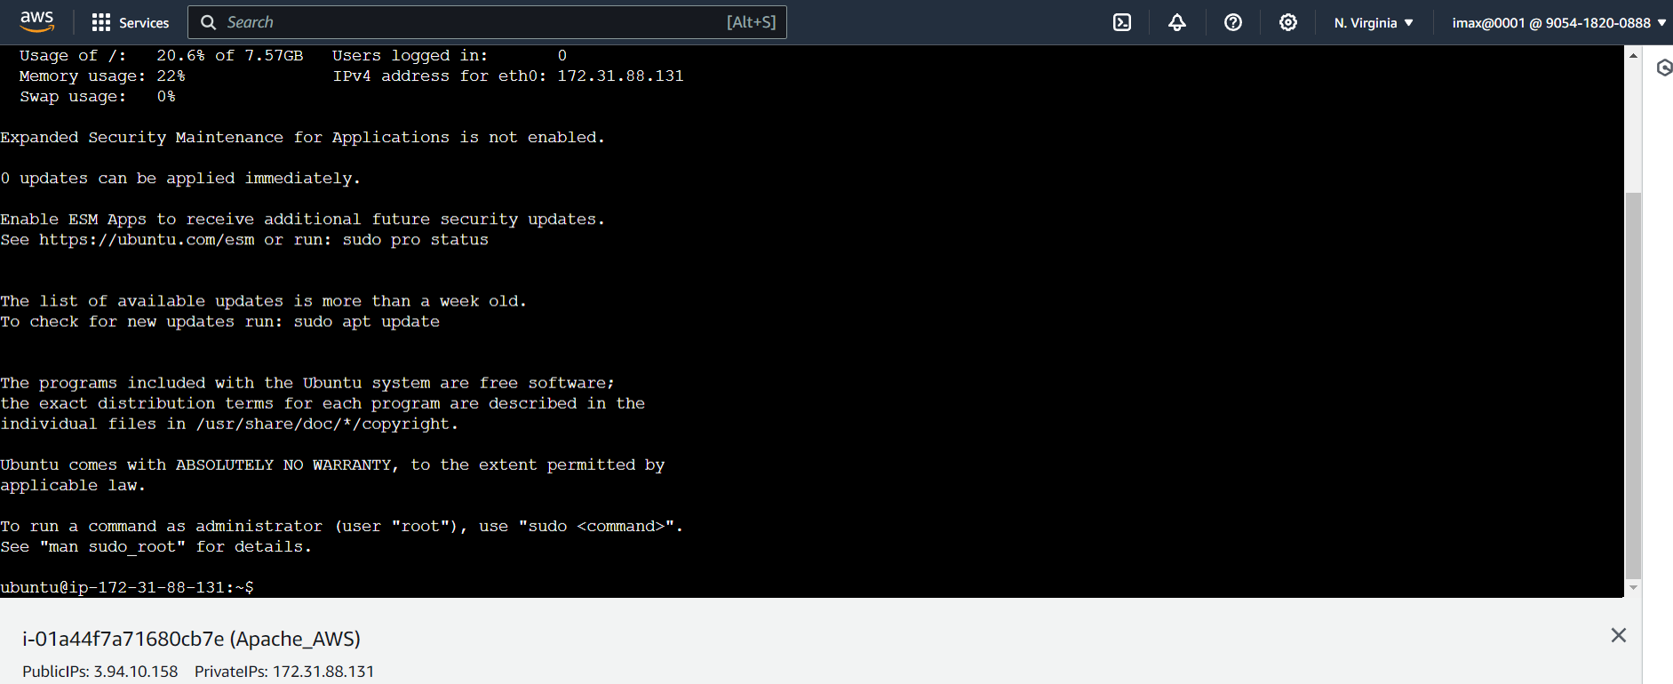

1. To ensure that the latest update and patches are installed by typing ‘sudo apt-get update’

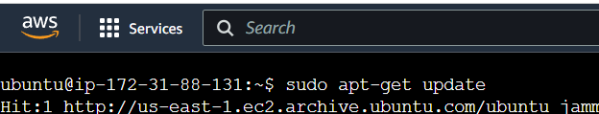

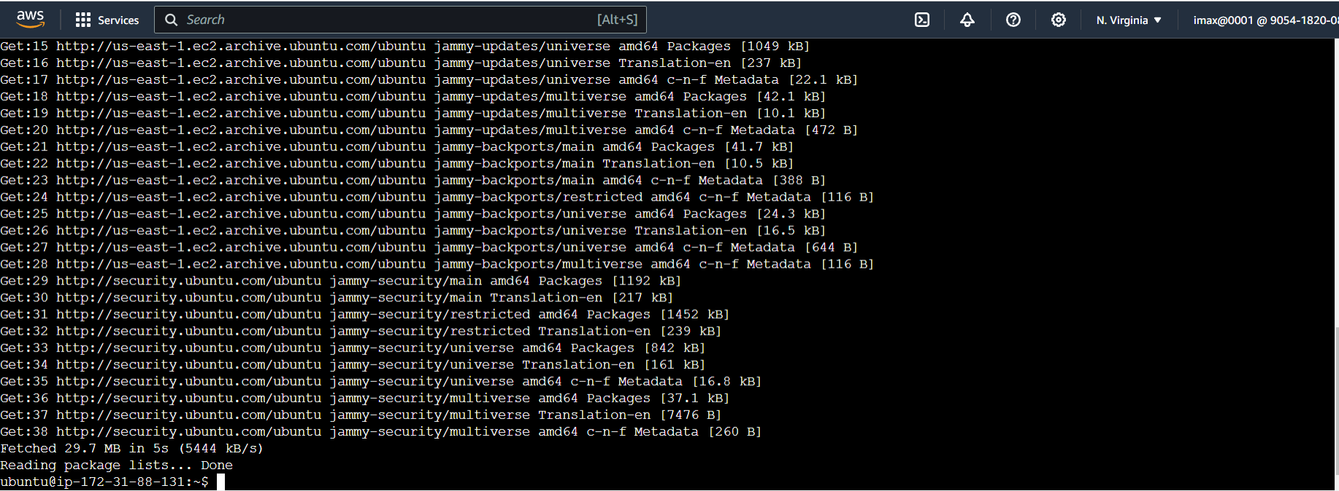

1. Installing Apache2 from ubuntu repositories by typing ‘sudo apt-get install apache2’

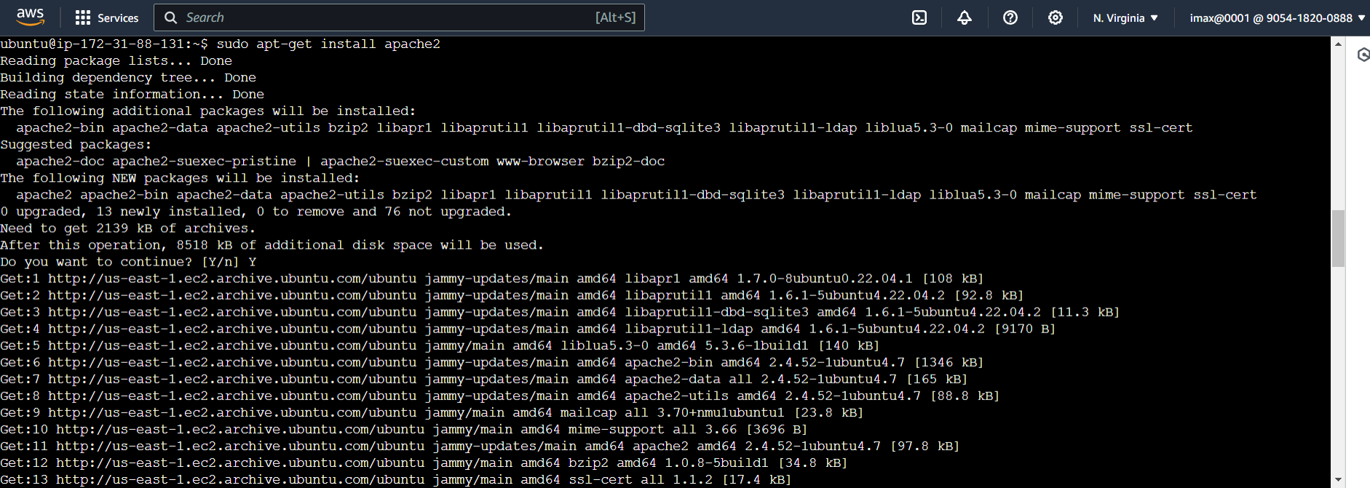

1. To check the version of Apache2 by typing ‘apache2’

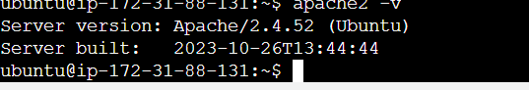

1. Verify that Apache is running using the command : sudo systemctl status apache2

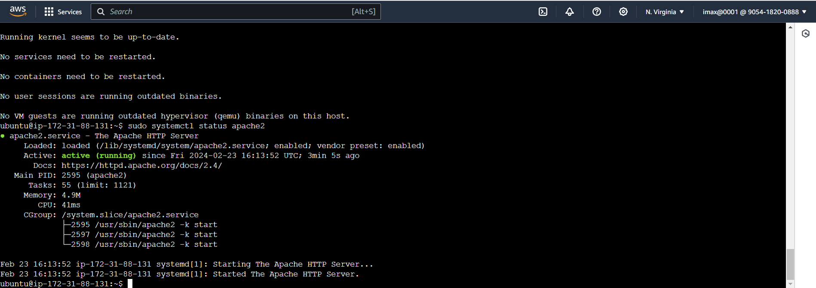

1. Go to web Browser hit Public Ip of that particular instance and see the default page of Apache2

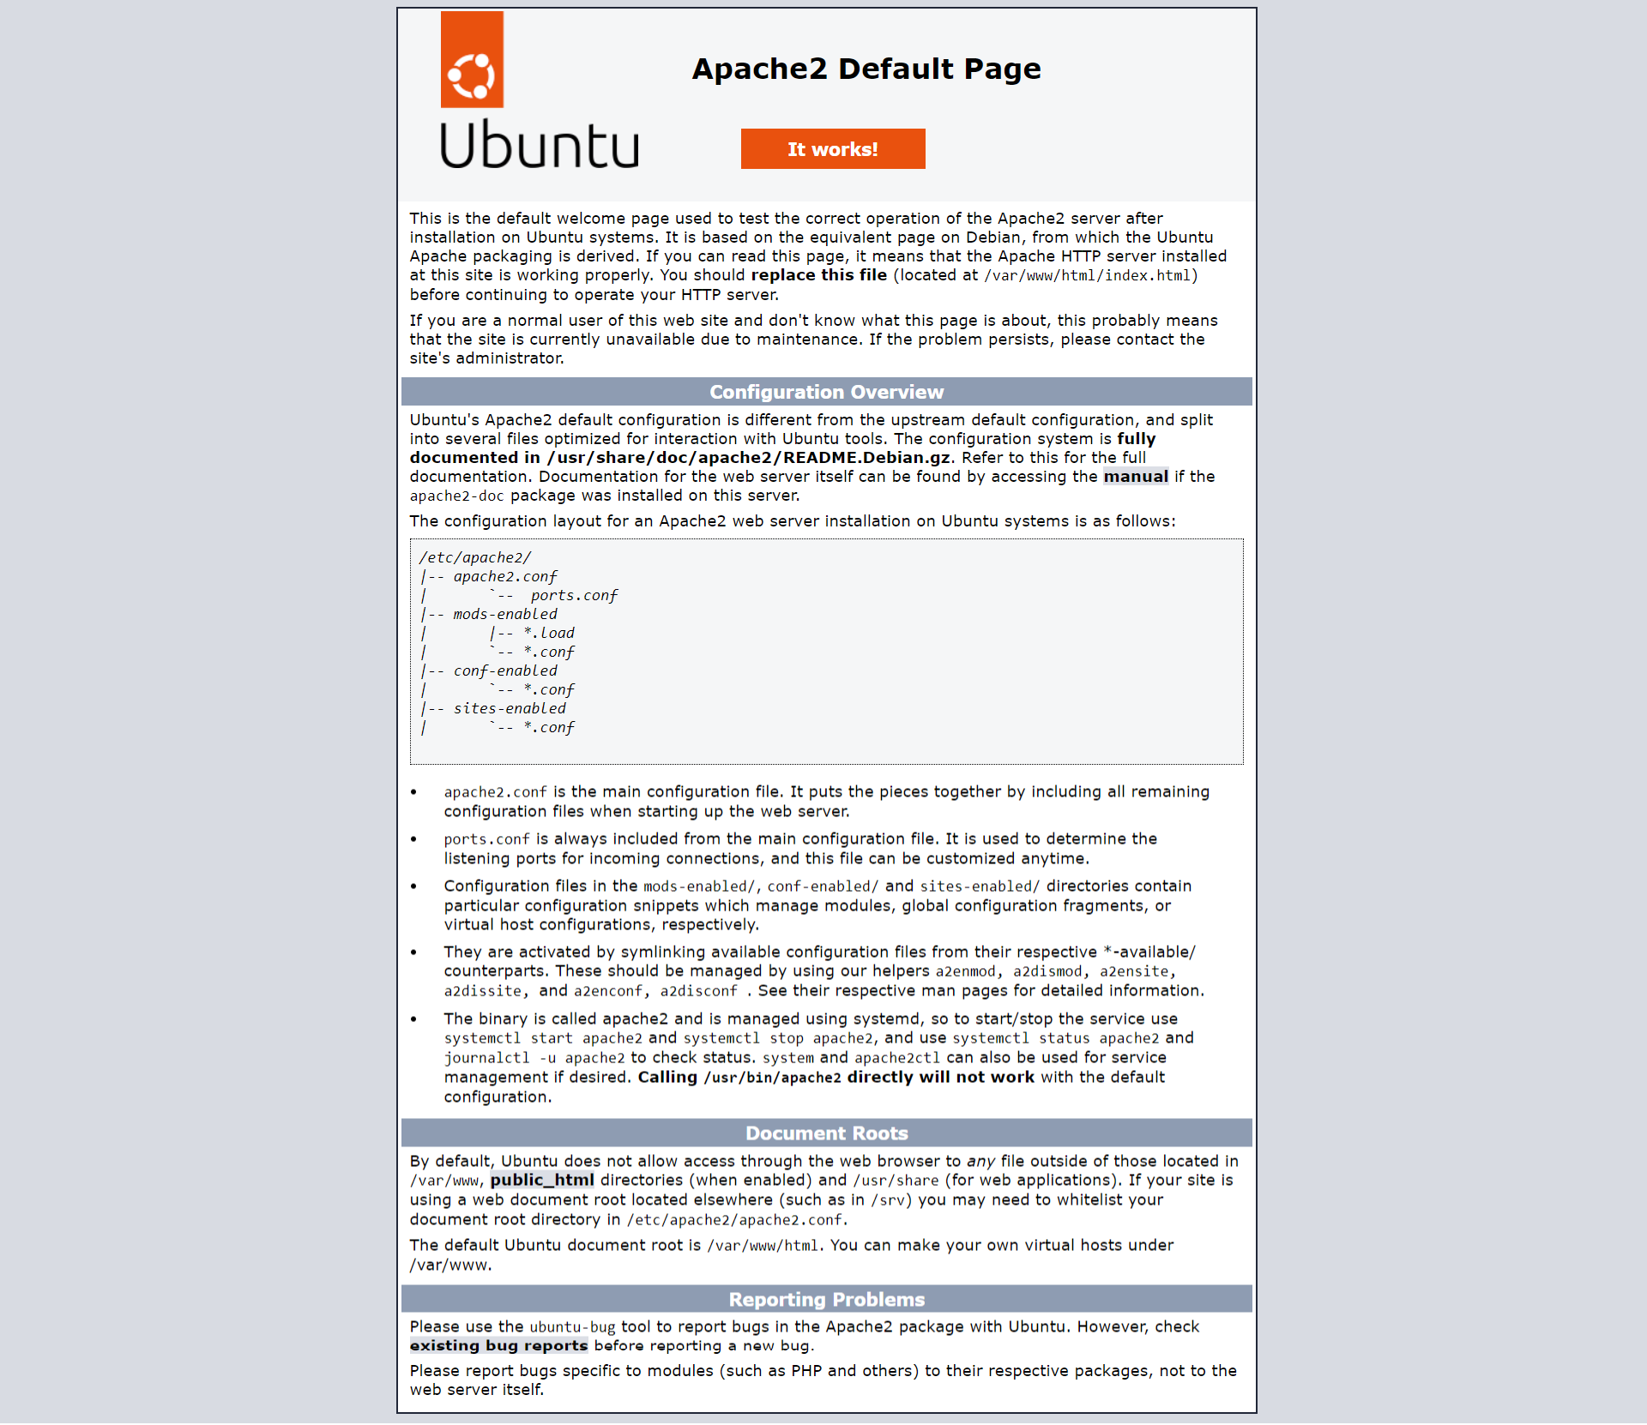

1. Then again go to our Instance page and see our public Ip(Now Public Ip is “54.227.194.118”)

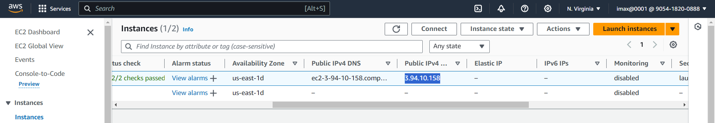

1. Stop the Instance for 1 min for selecting ‘Stop Instance’

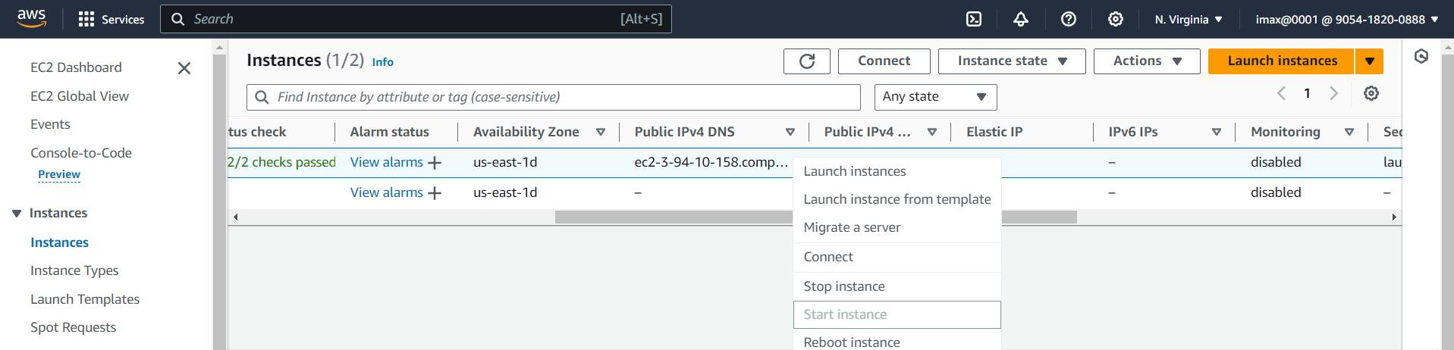

1. Click on stop

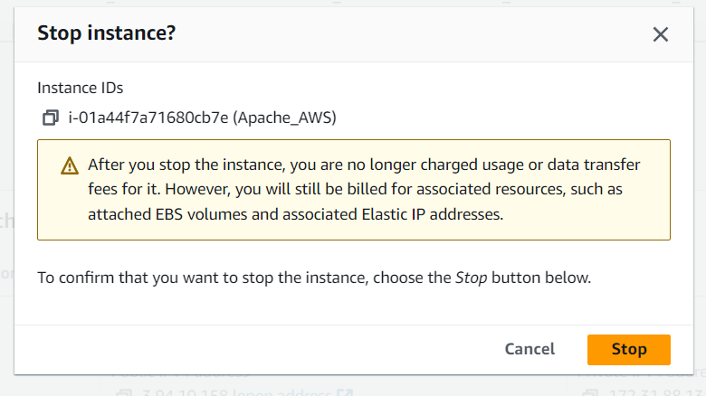

1. After Some time Start the Instance

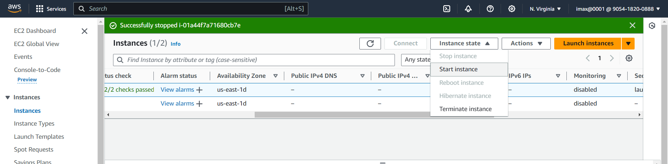

1. Now the public Ip is get Change(Public Ip“44.203.55.13”)

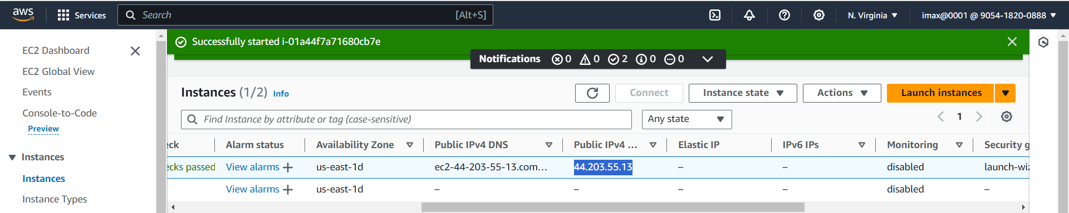

1. Hit that public Ip on web browser

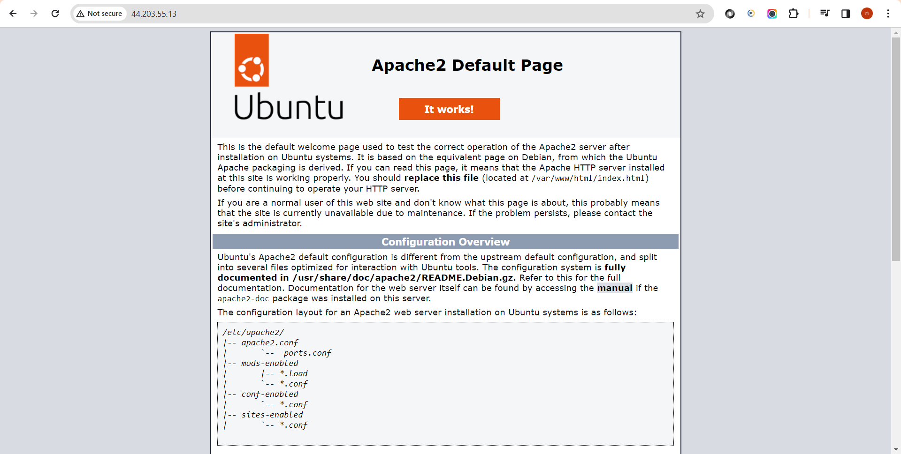

1. Go to instance page and terminate the Instance

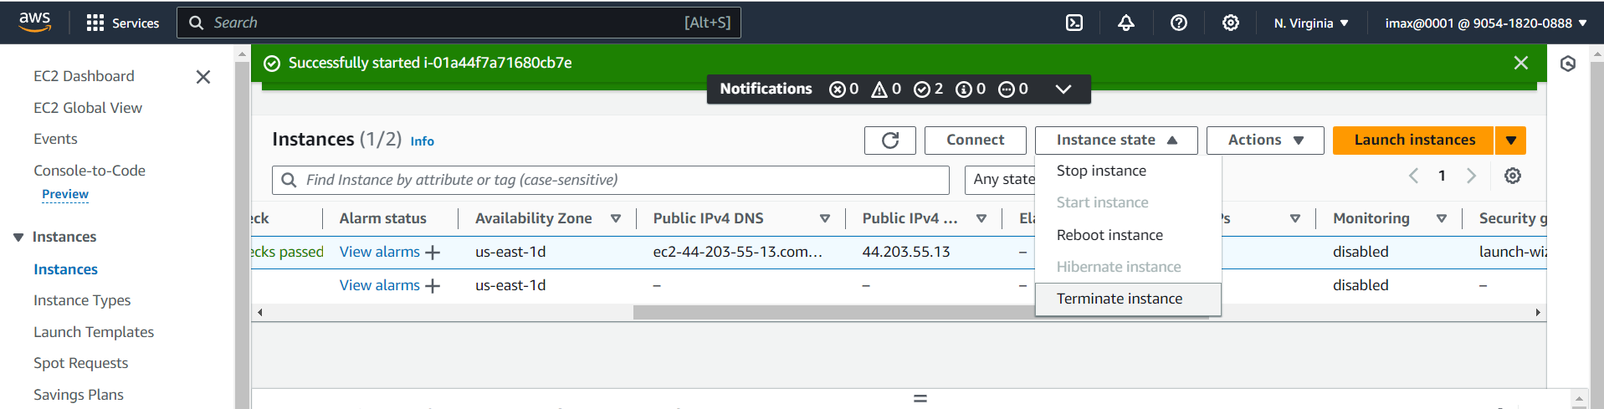

1. Click on terminate

